The Design Of Garment Enterprise Data Warehouse Using The TOGAF Framework

Ni Putu Sri Merta Suryani^{1*}, Putu Bagus Indra Sukadiana Putra², and Komang Oka Saputra³
^{1,2}Department of Electrical and Computer Engineering, Post Graduate Program, Udayana University
³Department of Electrical and Computer Engineering, Udayana University
*Email: mertasuryani@gmail.com

Abstract— Garment company is a company that is recycling fabric into apparel. Processing through several phases i.e. Setup process materials, production planning to produce a product. In the garment companyhas units that administered by the manager. The unit i.e. warehouses, production, marketing, human resources and finance. As time goes by, followed by information technology which is increasingly growing, the company needs a system of information that is in tune with the business processes of the company. For it takes a data warehouse technology, so need to built an integrated information system between units. Enterprise Architecture is the method used in building an enterprise architecture. One of the frameworks used in building an information system is TOGAF. TOGAF is used as a step in establishing a system of information in the future can support the business activities of the company.
Keywords: Data Warehouse Enterprise Architecture, Garment, TOGAF

Introduction

The role of information technology in a company is very important. Information technology provides convenience in carrying out business activities of the company. The application of information technology are concerned with has to be aligned with business strategies and processes in the company. The alignment is done in order to achieve the desired target by the company.
Garment company is a company engaged in the field of business. Garment company is a company that is recycling fabric into apparel. The next apparel products marketed or delivered to consumers who book in advance. The production process begins by checking the ingredients in the barn, after checking is performed, the materials processed in unit production to the finished product and subsequently submitted to the unit's products and marketing.
In running its business processes, the company experienced some problems of the garment. The problem is the analysis and reporting on any units still manually so that the company's business activity is inhibited. The existence of these problems, a concern for the stakeholders to build an integrated information system in this company.
Problems on the garment company overcome by building a data warehouse with enterprise architecture. Enterprise architecture has a useful framework for the development of enterprise architecture. The framework is applied in future can enhance the entire business process in the company's garment.

literature review

  - Garment Company.
The company's garment was the company processing the fabric into apparel products. The company has garment units such as warehouses, manufacturing, human resources, marketing and finance. Each unit is administered by a manager. Stages in processing the fabric into apparel started from the checking of materials in warehouses, in the production process is carried out to produce a garment so that it is ready to be marketed until sent to the customer.
  - Information Systems
Information system is a combination of information technology and the activities of people who use those technologies to support the operation and management. Information systems process data into information useful for its users. Information systems can be categorized into 4 (four) i.e. information management system, system information, system decisions and executive information system processing the transaction.
  - Data Warehouse
Data warehouse is a set of data that is stored in a multidimensional storage and is designed for querying and reporting. There are four (4) the characteristics of the data warehouse is organized, subject oriented, non volatile and time variant.

  - Enterprise Architecture
Enterprise architecture is the process of translating the vision and strategy of a business to change in a more effective way to create, communicate and improve key needs, principles and models that describe the State of the company during the future and ensure the company to evolve into better [Wikipedia, 2012]. Enterprise architecture defines what companies do, who run the company individually, how functional the company that will run and how the company's data will be stored and utilized. The use of enterprise architecture in the company aimed at improving the effectiveness and efficiency of the business of the company.

  - Enterprise Information System
Enterprise Information System is a system that provides a service that aims to improve the effectiveness and efficiency of activities of the company. Companies that implement the information system aims to let the existence of integration between units.
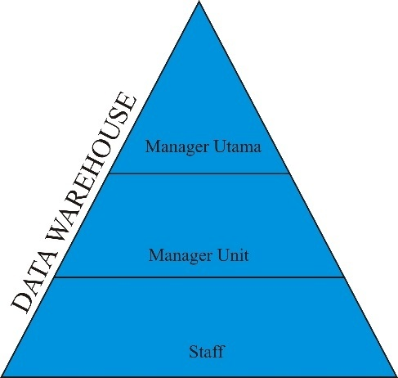
Figure 1. An Overview Of Enterprise Architecture Empire State Building
In Figure 1 there is the image of the enterprise architecture garment. Garment companies which implement enterprise information system will certainly ease. It is because the data that is in each unit is already integrated with other units. These units include the warehouse, finance, HR, marketing, production and payroll. The existence of data integration in each unit will be able to improve the business processes of the company.

  - Framework Enterprise Architecture
There are a variety of frameworks used in the development of enterprise architecture. The framework identifies the information that is required to describe the enterprise architecture. Enterprise architecture frameworks including TOGAF Zachman Framework and namely the Framework.

TOGAF FRAMEWORK
The Open Group Architecture Technique (TOGAF) is a framework developed by The Open Group's Architecture Framework. TOGAF is used to develop enterprise architecture because it has method that detail when applied. There are four categories in the TOGAF i.e. business architecture, application architecture, data architecture and technical architecture. One of the components of the TOGAF Architecture Development Method is (ADM).
Architecture Development Method (ADM) is a major part of TOGAF which gives an overview of the details of how to define the enterprise architecture in accordance with the business requirements of the company. As for the description of the ADM cycle consisting of 8 (eight) phases can be seen in Figure 2.
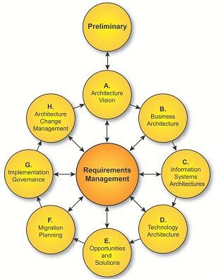
Figure 2. The Cycle Of ADM
Figure 2 represents the cycle of ADM. ADM Cycle consists of a preliminary phase, the architecture vision, business architecture, information system architecture, technology architecture, opportunities and solutions, migration planning, implementation governance and architecture change management. In this research are discussed from a preliminary phase to fae opportunities solutions.

THE DESIGN OF THE DATA WAREHOUSE WITH THE METHOD TOGAF
Stages in the design of the data warehouse on the company's garment with method TOGAF.
  - Preliminary
At the stage of preliminary carried identificaton towards enterprise architecture scope, identification of resources required in the datawarehouse design company, set a framework that will be used by enterprise architecture build and define the principles of architecture. At this stage the identified business process related to garment enterprise data warehouse. The main business process activities on the company's garment described in table 1.
Table 1. Identification Of Business Processes
Pre Production | - The process of ordering materials.  - The process of checking inventory.  - The process of logging and reporting materials.
Production | - The process of checking stock material.  - The production process.  - The process of logging and reporting of production.
Post Production | - The process of product marketing.  - The process of shipping products.  - The process of logging and reporting products.

On table 1. Describes the identification of business processes on the design of the data warehouse on a garment company. At a preliminary stage of the process, there is a major activity with 3 (three) business processes.

  - Architecture Vision
Stages of the architecture vision is done the process of aligning the vision of architecture in the design of the data warehouse. The vision of architecture in designing corporate datawarehouse garment as follows:
- Build an integrated data warehouse design in order to streamline the business processes of the company's garment.
- Can provide information that is accurate, precise and fast for a user in each unit of the company's garment.

  - Business Architecture
Business architecture is a business process that is already underway at this time. Business processes are identified, then proceed with determining the expected business model. On the design of the data warehouse, business architecture can be seen in table 2.
Table 2. Business Architecture
Business process pre production | - Plan materials.  - Checking of stock material.  - Packing material for manufactured.
Business process production | - Checking of stock materials in storage.  - Retrieval of materials in the warehouse.  - The implementation of product manufacturing.
Business process post production | - Checking products.  - Product marketing.  - Product delivery.

In table 2. explain that there are three (3) business process agreed on the company's garment. The business process business process i.e., pre production, business processes of production and post production business processes.

  - Information System Architecture
On the phases of information system architecture implemented modeling the data warehouse architecture will be designed. At this stage defines the type of applications that are required to manage the data and support the business processes of the company. In this stage will be discussed regarding data architecture and application architecture that will be implemented in the organization. Application architecture put more emphasis on the needs of applications that support the business processes of the company. As for the applications that support the business processes including :
- Pre production
  - Booking application
  - Inventory application
- Production
  - Materials processing application
  - Product application
- Post Production
  - Marketing application
  - Delivery application
Data architecture put more emphasis on the identification of the dimension. Dimensions obtained from identification of the important attributes that exist in the data. For more details are described in table 3.
Table 3. Data Architecture
Material Dimension | Processing Dimension | Operator Dimension | Staff Dimension
Material Stock Dimension | Time Dimension | Marketing Dimension | Production Dimension
Material Order Dimension | Product Dimension | Shipping Dimension | Design Dimension

In the table 3. explained about the right dimensions in supporting business processes the company's garment. Further identification was done between the information and the application of what is desirable in order to provided in a data warehouse fact table to produce.
- Fact Table Payment
- Fact Table Sales
- Fact Table Complaint
- Fact Table Order
- Fact Table Purchase

  - Architecture Technology
In this phase, conducted an examination of the existing computer network related companies. The image of architecture technologies to the design of data warehouse in garment company can be seen in Figure 4.
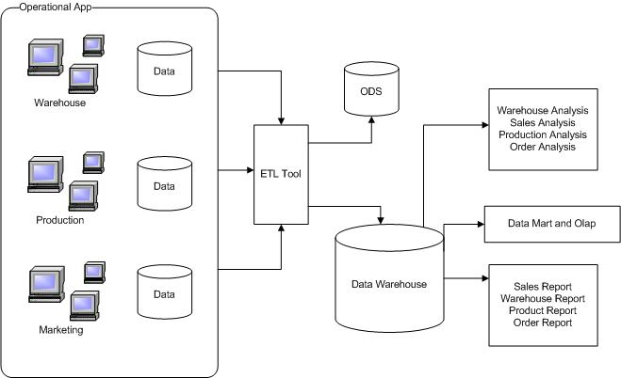
Figure 4. Network Architecture

  - Opportunities and Solutions
In this phase of the evaluation will be performed by selecting the implementation plan, alternative implementation and implementation strategies. The solution given in data warehouse design with method TOGAF and provides what is needed by the company's garment. There are a couple of things and strategies primed in an effort to minimize the risk as follows:
- Design and Development Time that was long enough.
- Huge cost.
Before applying the system, done will need to test against the data warehouse has been designed. In addition a need for training for staff in the use of the system and records all activities performed on the system.

conclusion
The design of data warehouse by using the method of TOGAF is done based on the needs of the company. Identifying data is very important to obtain the fact table. By implementing data warehouse, the company's garment can obtain data that is accurate, fast and precise.

References
- Inmon,W.H., Building the Data Warehouse, Fourth Edition, Wiley. 2005.
- R. Harrison, “Study Guide TOGAF 9 Foundation,” The Open Group, 2009.
- Kusuma Ayu. Perancangan Data Warehouse dengan Pendekatan Enterprise Architecture. 2010.
- Kimball, R.,Merz, R. The DataWarehouse Lifecycle Toolkit. Expert Methodsfor Designing, Developing and Deploying Data Warehouses. Wiley Computer Publishing,Canada. 1998.
- Gustiarahman, Irfan. Data Warehouse. Jakarta. 2006.
- Session, Roger. Comparison of Top Four Enterprise Architecture Methodologies Object Watch.Inc. 2007.
- The Open Group. TOGAF (The Open Group Architecture Framework) V 8.1.1. Enterprise Edition.2003. www.opengroup.com
- R Harrison. Study Guide TOGAF 9 Foundation. The Open Group. 2009.
- Aradea, Damacita, Mubarok. Perancangan Enterprise Architecture untuk pembuatan Blueprint Teknologi Informasi Rumah Sakit. Prosiding Seminar Nasional Ilmu Komputer. Vol 1 No 7.
- Santi IM, Angelina WG, Indah CD. Design of Enterprise Information System with TOGAF Framework (Case Study : STD Bali. International Journal of Engineering and Emerging Technology. Vol 1 No 1. 2016.
- JM Sinambela, “Integrasi Sistem Informasi,” Program Kerja Tim Integrasi Database dan Sistem Informasi Gajah Mada, 2011.

