CARTOON VISUALIZATION AS SOCIAL REPRESENTATION IN BOG-BOG BALI CARTOON MAGAZINE 2011/2012 EDITION

I Wayan Swandi
AA Bagus Wirawan
I Nyoman Artayasa
I Gede Mudana

ABSTRACT:
Bog-Bog cartoon was a mass media production which was rich in strong artistic and Balinese cultural values. Social changes cannot be avoided since Bali became a global tourist destination. On one hand, Bali cannot be avoided from being attracted by the global strength; on the other hand, attempts are perpetually made to maintain its cultural identity. The descriptive method was used in the present study, which was intended to explain how the Bog-Bog cartoon was visualized and what meanings were hidden in it.
Keywords: Visualization, Cartoon, Bog-Bog Magazine, Social Representation

INTRODUCTION
As far as the Balinese culture is concerned, cartoon is not a strange thing as it cannot be separated from the traditional art of painting in general and the puppetry art in particular. Traditionally, in Bali cartoon is better known as prasi. The prasi pictures are painted on the palm leaf using a sharp knife referred to as pengerupak. In Bali the prasi art has been developed in Karangasem, exactly at Tenganan Pegeringsingan Village with the themes adopted from the Ramayana and Mahabrata epics. Klungkung has been popular for its Kamasan puppet since 17th century. The technique used to paint the Kamasan puppet is similar to that used to paint the modern cartoon pictures.
There were several reasons why the Bog-Bog Cartoon Magazine was used as the object of the study. First, it is a magazine which uses cartoon as the medium for illustrating the messages transmitted to the readers. Second, it is the only carton magazine which uses the Balinese characters within the local scope and national scope. The fact that it has acquired the Muri Award proves this. It has attracted the cartoon observers from the other countries as the image of Bali is so strong to the academicians and international cultural researchers that it has a relatively high selling value and bargaining position. This opportunity was used by the Bog-Bog cartoonists to work together with the global cartoonists in 2003. It has been the first cartoon magazine with the Balinese cultural nuance.
The other reason why the Bog-Bog Cartoon Magazine was chosen as the object of the study was that, ideologically, it activated, persuaded and informed things to people in a subtle and humorous way or using satires. In addition, the pictures it contained also represented the social phenomena in Bali. Every theme contained meaningful, real and complex massages. The concepts which the Bog-Bog cartoon contained had been well planned before. Then such concepts were visually presented and read by the public.
Visually, the cartoon, as social representation in the Bog-Bog magazine, was the final result of the deconstruction of the form of the cartoon made by the cartoonists to carry the flag of the Bog-Bog Bali Cartoon Magazine. The Balinese traditional nuance concept consistently became the icon of the cartoon form every time the magazine was published, meaning that the attempt made to realize the image of the art work produced by the cartoonists that supported the Bog-Bog magazine showed the specific characteristic of the magazine. Therefore, this present study was intended to reveal the concepts related to the form and meaning of cartoon through the study which explored the whole process of creation, the contextualization of creation, the internal and external impacts and so forth.

METHOD
This present study which explored the Bog-Bog Magazine is an interpretative and descriptive study. This method was used to explain the visual aspects and meanings of the Bog-Bog cartoon as the Balinese social/cultural representation. The drawings which were published in the Bog-Bog magazine published in 2011/2012 were used as the data source. The data were also obtained by interviewing three cartoonists and the founder the Bog-Bog Magazine. In addition, the data needed were also obtained by interviewing several social observers who understood the function of the Bog-Bog magazine as the social representation. The study was conducted in Denpasar City where the magazine was circulated. The study was also conducted in the secretariat of the Bog-Bog Magazine. The data were analyzed using the postmodern aesthetic theory and the theory of semiotics. From the analysis, it could be identified that ideologically the visual aspect played a role as a medium which could reconstruct realities.

RESULT AND DISCUSSION
In Bali the cartoon world has been felt since 1977; it was initiated by a group of cartoonists who worked for the local newspaper “the Bali Post”. The themes dominantly presented social criticisms with strongly humorous nuance on the Opinion page (the editorial cartoon). The Bali Post newspaper is the foster father of most of the current Balinese cartoonists. At least it, as the biggest newspaper in Bali, has created the cartoonists. In addition, it has also raised them in such a way that they, including the Bog-Bog ones, have become independent.
The Bog-Bog cartoon magazine was firstly published in 2001 by a cartoonist who was born in Denpasar. His full name is Made Gede Parama Artha; therefore, he is often called Jango Pramartha. At that time he did not work by himself; he was assisted by two co-founders named I Gusti Putu Adi Supardhia who is better known as Putu Ebo and Cece Riberu. They worked as cartoonists. Since the Bog-Bog cartoon magazine was firstly published, the sales of the magazine have exceeded what was expected by the founder. Its national and international circulation has proved this.
The readers of the magazine can be grouped based on their ages, educational background, and economic status. According to Jango, the magazine is published not to be consumed by children, although it can be enjoyed by every family member. It contains social, political, cultural and art issues. The magazine is also read by different layers of society, starting from the common people, academicians, politicians, those who are involved in the non-government organizations and so forth.
The Bog-Bog cartoon is strongly characterized by the Balinese cultural characteristics which include the fashion system. As an illustration, most of the male characters wear head cover ‘udeng’, sarong, and frangipani ‘bunga kamboja’, and the female ones wear blouse ‘kebaya’, cloth ‘kamben’, and hair bun ‘sanggul’, In addition, their names are also adopted from the common Balinese idioms such as Made Bogler, Ketut Cenik and Kapler Kaplug. (See the attached pictures).
The character Made Bogler was painted by Cece Ribero. The name Bogler is derived from the word “bogler”, meaning ‘tengil’ or ‘pecicilan’. According to Cece Ribero, the character Made Bogler depicts the characteristics of the Balinese people who are funny, talk as they like, always show their teeth, and are naïve. Ketut Cenik in “Ketut Cenik Learning to Dance” was painted by Putu Eco and represented the Balinese young people who care about the traditional Balinese culture in general and the traditional Balinese dances in particular. The name Cenik is derived from an anonymous song which was popular in the past. The content of such a song predicted the changes which would take place in Bali, resulting from the arrival of the white people. Kapler Kaplug was painted by Putu Ebo depicting a specific young naughty man. Kapler was painted with the make-up which was similar to the make-up worn by Elvis Presly. However, Kaplug depicted a wise young man who was often involved in the naughtiness in which Kapler was involved. They were young men who cared about the matters pertaining to the social environment where they lived.
The discourse on globalization has been used as the great theme in the Bog-Bog cartoon. According to the informants, globalization has become the endless inspiration. It should be explored within the globalization context. Foreign culture is interfering and will interfere with the Balinese people’s life. In an interview Jango told the social changes which were taking place in Bali as a consequence of globalization as follows.
[The theme and general target of the Bog-Bog Magazine can be found in the word Glo-Bali-sasi which contains the word Bali. Basically, the theme which is understood by the common people is how we adopt the social changes taking place in Bali. From such social changes we search out what is unique which is then transferred through cartoon. As an illustration, golf can destruct us as it is played by a few players but it needs a lot of land”].
It cannot be denied that globalization in Bali is enthusiastically welcome by people. In Picture 1 the word “globalization” was intentionally written in red, indicating a condition in which we should be on the alert. It also indicated a danger and reminded us that Bali had been exploited within the discourse on globalization. Under the word ‘globalization’ two people were seen to represent the local people who enthusiastically said “Yes” (the dollar currency was the character). They were bringing subjugated commodities, implicitly meaning that they enthusiastically went up the economic ladder or the economic improvement.

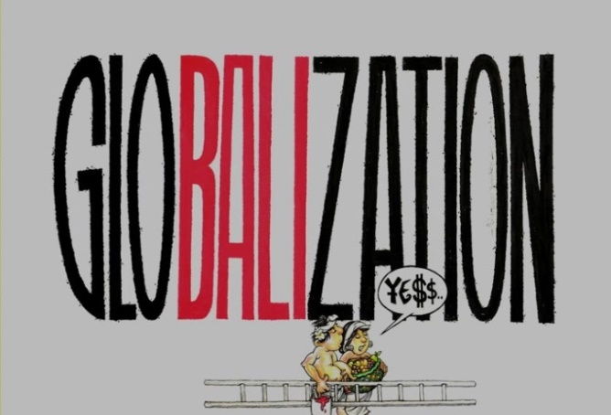
Picture 1. Globalization. Globalization in Bali was used as the theme of one of the Bog-Bog works exhibited at Freemantle Art Center in Perth, Australia. Such a great theme was used by the Bog-Bog cartoonists in Bali to respond to the socio-cultural phenomena in Bali. It was agreed by the Bog-Bog founders. Source: Film Dokumenter Return Economic.
The Bog-Bog Bali Cartoon Magazine used “Globalization” as its great theme as anticipation to the social changes which had taken place rapidly and massively in Bali. The reason was that globalization had changed the socio-cultural landscapes in Bali. According to Jango, Bali could not avoid the ideology of globalization, and the Bog-Bog cartoon should also be able to take the opportunity offered by globalization. As already known that the trap of the globalization ideology works through the changes taking place in the landscapes of the world referred to as the Ethnoscapes, Mediascapes, Technoscapes, Finanscapes, and Ideoscapes (Appadurai, 1990: 329-331).
As anticipation to the cultural change, the Balinese people welcome and adopt changes flexibly and selectively (Geriya, 2000). Drawing 2 showed two priests “mangku” who were reading holy books. One was reading the palm leaf manuscript and the other was using a tablet. Such a phenomenon showed that the Balinese people were in the transformational process; the traditional mechanical tool was being replaced by the modern mechanical tool.

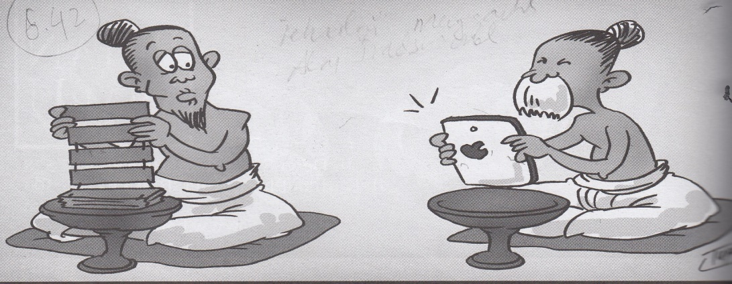
Drawing 2 Tablet Vs. Palm-leaf Manuscript (Theme Globalization). A social phenomenon of how a technology interfered with a spiritual activity which is generally conservative and traditional in nature. Source: the Bog-Bog Cartoon Magazine No. 5 Vol. 10 of 2011.
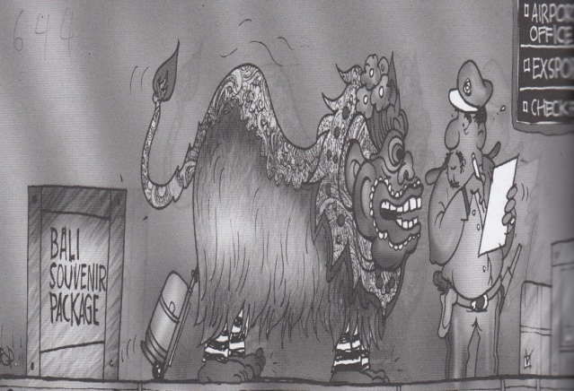
Drawing 3 Milk-Coffee (Theme Globalization). Tourism was the entrance to traditional crimes in Bali; the black spot was the entrance to the airport. Source: Bog-Bog Cartoon Magazine No. 6 Vol. 10 of 2011
The globalized Bali attracts and motivates tourists to come. According to the Board of the Center of Statistics, the number of tourists coming to Bali in general and to Denpasar in particular has increased by four percent annually. The study undertaken by Amminulah showed that there was a correlation between the increase in the number of population and the number of crimes in Bali. Drawing 3 showed the checkpoint at the airport. An immigration officer was exploring what is referred to as Barong. Within the barong two criminals were found wearing the costume with black lines as worn by prisoners.
In 2013 the crimes taking place in Bali totaled 8,420, in 78 of which 83 foreigners were involved. The criminals in Bali are not only Indonesians but also foreigners. The black spots were the gates through which they could enter and leave Bali, meaning that they were trapped at the airport. One of the cases which was spotlighted by both the national and foreign mass media was the Bali Nine, namely the narcotic Australian syndicate that was caught smuggling narcotics. The fact that there was an international syndicate that had broken into the Automatic Teller Machines in Bali for the last ten years leading to a loss totaling quintillions of rupiahs was another big case. Apart from that, Bali has also been the target of the international terrorism. Many studies have been undertaken to explore the correlation between terrorism and globalization. It was stated in the global research that the terrorism attack at Legian Kuta, Bali, in October 2002, was made by the international terrorism.
Globalization has also become the access to the international spread of crimes and narcotics. According to Findlay (1999:103), social changes result from globalization. As an illustration, particular groups of people are getting marginalized and this may lead to crimes. The same thing is stated by Harvey et al. (in Findlay, 1999) that “globalization creates new and favorable contexts of crime”. Globalization leads to the climate which can support crimes.
The Visual Presentation of Cartoon in the Bog-Bog Bali Cartoon Magazine Edition 2011/2012
The visual presentation of cartoon in the Bog-Bog Bali Cartoon Magazine showed that the norms of the modern and classical arts had been ignored. The aesthetic elements which were offered were vulgar, resulting from the impact of the postmodern style. Baudrillard (in Piliang, 2011) stated that the postmodern art was vulgar and had lost its secret dimensions. In the graphic art, the visual presentation of a graphic work can be viewed from several elements such as the form, character, color, and layout. According to Lester (2003), as far as the cartoon characteristics are concerned, the important signs which are importantly needed to know cartoon are the frame, background, setting, characters, motion lines, typography and balloons. Such visual signs distinguish the classical art works from the modern ones.
Visualization is the most accurate way in which something which is abstract can be made to be clearer. The visual presentation can always attract the reader’s emotion and can help someone analyze, plan and decide a problem before comprehending it (Kusmiati, 1999: 85-86). Visually, the postmodern art works such as cartoon have made themselves different from the modern and classical art ones, as can be seen from the shape, color, frame, and different visual elements used in cartoon such as motionlines, typography, and word balloon. Humors in cartoon can be transmitted through drawings and verbal language. Although picture can present stories, the supporting factors such as the drawing panel and text cannot be ignored (Hidayat, 1998: 183).
From the perspective of shape, the Bog-Bog cartoon can be classified as the cartoon shape which imitates the original shape such as human being as can be seen in the cartoon “Made Bogler”, “Kapler Kaplug”, “Salon Celuluk”, “Multitasking”, Poleng Nomor 1” and so forth. In addition, an animal was drawn in the cartoon “Multiasking”, a tree in the cartoon “Pohon Iklan” (Tree of Advertisements), and inanimate objects such as cars drawn in the cartoon “Kemacetan” (Traffic Jam). (Refer to the attached drawings!). The art cartoon is stated to be the postmodern work which is characterized as the work of imitation imitating the original objects (Baudrillard, 2002). According to Rose (1993: 29—30), cartoon is a parody using the imitating technique. As in the other postmodern works, quality is not determined by originality, complexity, subtleness, and the formal expression which is proportional to the content (Barker, 2005:57). Similarly, in cartoon quality is not determined by originality, complexity and subtleness either.
The drawings of the original objects are distorted in order to give humorous and parody effects. The distorted drawings visually criticize characters. According to Low (1984:728), such a distortion is representative and symbolic, and shows satires, smartness, and humors. It is intentionally made especially if cartoon has political content.
The imitated objects in cartoon are not only distorted but they are also completed with the line actions. Motion lines are the imaginary lines which depict the traces of the physical movements made by the characters. As an illustration, the motion lines in the drawing of “Salon Celuluk” gave trembling effects that expressed the feeling of being frightened as can be seen in the traces of the foot movements in the cartoon “Multiasking”, and so forth. Such motion lines were intentionally made in cartoon in order to give the exaggerated effect: “Notice how the eyes jump from the face of the character and how the body is stiff. This is an exaggerated representation of a natural reaction we have in real life” (Cabral, 2013). Such distorting techniques are parts of the parody elements which are not known in the fine arts such as the art of painting.
The drawing “Radio Made Bogler” with the theme “Radio” was a work with asymmetric multi frames. The same thing can be seen in the drawing “multi-tasking”, and “pohon iklan” (trees of advertisements). In the classical and modern arts the single frame is the norm. The panel is used to maintain continuity and explain what is expected or what the following sequence (McCloud, 2002) is. Modernism trusts regularity and rational formalism. In the postmodern art work, nothing regulates the number of frames. Postmodernism neglects the social cultural construction or order which is rationally constructed by the postmodern way of thinking.
The drawings of cartoon in the Bog-Bog Cartoon Magazine, except those in the “Kapler Kaplug”, used minimal texts with a ratio of 90 percent visual to 10 percent textual. In the fine art, a text is only an addition; the strength of an idea is in the drawing (Gumelar, 2013: 72—74). The text in cartoon is written using the word balloons as can be seen from the drawings “Radio Made Bogler” and “Kapler Kaplug”. Such a text usually constructs a dialogue between the characters in the cartoon. However, there are several texts which are not written using the word balloons as can be seen in the images “Multiasking” and “Pohon Iklan”. Such texts are present to inform, express images or messages visually (Kusrianto, 2007:191).
A text is used to show a dialogue between the characters. Some words are sometimes stressed or printed in bold or using specific typographic forms. The presence of a text using typographic forms causes the cartoon art to be difficult to be differentiated from the press. As already known that press is a mass cultural product. Postmodernism causes the boundaries between the great art and the popular art (mass culture) to be vague. According to Featherstone (1993), the permissive eclecticism and the mixture of parody, irony, the appreciation of what is seen in the surface without identifying the meaning and the decrease in originality are responsible for such vagueness.
If categorized, the Bog-Bog cartoon can be classified as strip cartoon, namely the loose (short) cartoon which is put within one box (panel, pen). The single frame cartoon can be seen in the caricature cartoon, humorous cartoon, and editorial cartoon. And the multi frame cartoon can be seen in the strip comic work. Unlike the classical art works which strongly maintain the structure, the postmodern works highly appreciate diversity, emphasize humorousness or parody. In addition, the latter is not a serious thing; it tends to present something which is broken rather than something which is neat and clean; it gives more emphasis on picturesque with slightly geometrically regularity.
Simple coloring technique was applied to most of the Bog-Bog cartoons. The cartoonist only used the technique of degrading black and white, the cover was excluded. Black and white are known to be simple, causing the message which is intended to be transmitted to be clearer. In this way, the reader can easily understand the massage which the drawings contain; the heavy display is tranquilized and minimum touch is added.
The principle in cartoon is that the content is more important; therefore, it has to help the readers find what they want to know. The use of black and white is intended to show that the focus is the function which is based on what is aimed at by the political, social and moral criticisms (Hidayat, 1999). In this case, the aesthetic element is not a priority. Therefore, according to Berger, cartoon cannot be classified as a high art product (Berger, 2005).
The media and printing technological development has caused the aesthetic elements to be reduced; as a result, taste and imagination are determined by machines and software. One of the sociological criticisms against postmodernism is that it does not offer any solution; it offers nothing new. From the aesthetical point of view, this can be understood from the fact that there are almost no measurements; moreover, it still owes to the classical and modern art theories. In addition, technologies make it possible for the cartoon works to be massively produced. The aim of the art works using repeated technologies of production and reproduction is the economic benefit (Featherstone, 1993).

The Parody Idiom in the Bog-Bog Cartoon Edition 2011/2012

From the aspect of its presentation, the Bog-Bog Bali Cartoon Magazine was more dominated by humorous drawings than the elements of words, phrases or sentences, indicating that the Bog-Bog magazine can be classified as verbal cartoon; however, the verbal element was not dominant, meaning that drawings were dominantly used to express messages and illicit laughter from the reader. In cartoon, the verbal elements represent speeches, and the humorous drawings serve as the extra lingual context of the speeches which usually show who the speaker is, who the addressee is (if present), the word spoken of, and the spatio-temporal setting which is related to where and when the speeches are uttered (Wijana, 2003: 10). The Indonesian and English words used to express messages in the Bog-Bog Bali Cartoon Magazine were short and simple.
As an art work, cartoon should also be assessed from the shape value and content value (Sumardjo, 2000:115). Although from the aspect of shape, cartoon shows a strong phenomenon of postmodernism, the content value appears more clearly than the shape value, meaning that the art of cartoon gives more emphasis on the significant shape than on the object of beauty. According to Bell (in Sumardjo, 2000:59), cartoon is the art of representation. The ‘shape’ in the art of representation is intended to evoke a particular emotion towards the information which is represented. According to Ajidarma (2012:18), the motion which is evoked in cartoon is the sense of humor (laughter) as the response to the parody element represented.
Parody specifically characterizes the style of the postmodern art (Rose, 1993:2). According to Hutcheon (2002:2—6), parody is defined as an inter-art discourse which is imitative and contains opposition or contrast. In general, the parody art expresses dissatisfaction, unhappiness, and discomfort which are related to the intensity of the past style or work which is referred to. In the graphic art such as cartoon, parody or humor is made through distorted shape, controversial value and the meaning of humor. Basically, the Bog-Bog cartoon relies on the parody virtue.
The form of parody presented in the drawing “Salon Celuluk” of the theme ‘salon’ combined several humorous elements such as contradictive and emotional effects. The contradictive element was made to be present through the creature ‘celuluk’ or ‘pung’ as the salon’s customer who came for manicure and pedicure. The element of being frightened was affirmed by the motion lines expressed from the faces of the mothers as the characters in the drawing. According to Freud (in Ajidarma: 2012), the elements of being frightened, tendentious, innocence, hostility, and sexual drive are the sources of humor. The relationship between the astral creature and human being shown is not unsual. In the theory of superiority and degradation proposed by Pluto, it is stated that the object which causes us to laugh is a funny, strange and digressing thing.
The parody in the drawing “Radio Made Bogler” was a topic of radio which emphasized the character’s aspect of innocence. This drawing was designed with a plot narrating the character’s growth (from childhood to adulthood) with a vague perception of radio and television. In this case, the plot starting from the phase of orientation, crisis and climax gave the reader’s mentality to absorb the humor. The character Made Bogler was drawn with wide laughter using the distorted drawing technique.
The cartoon “Layang-Layang” (Kite) in the theme “Topi” (Hat) was originally adopted from a habit of the Balinese people, namely flying kite. According to Ajidarma (2012:25), a humor will be well accepted if it emphasizes the elements of originality and simplicity or if it is deeply rooted in the community which supports it; it should implicitly rather than explicitly satires something. As far as the cartoon “Layang-Layang” is concerned, it was a satire on impractical education.
A humor can be made to be present from the domestic areas such as daily life. In the drawing “Multitasking” of the theme “Waktu” (Time), a humor was made to be present by presenting the habit of the Balinese people who have multiple lives in their professions. The familiar domestic areas which include cow, sickle, grass, and art studio represent the current Balinese culture in which the traditional life is mixed with the context of modernity.
In the cartoon “Poleng No. 1” of the theme “Piala” the humor was made to be present in the form of a joke. The drawing connected the Balinese people’s belief with the sacred symbols expressed in their daily life. The conflicts resulting from the harassment of sacred symbols by particular people often occurred. However, in this humor the cartoonist still showed appropriateness to avoid the narrator’s internal inhibition as to something which was forbidden in society. According to Wijana (2003: 12), a humor is a cultural code as well as a linguistic code which is only understood and can be defined by the society which supports it. According to the non-Balinese people, such a cartoon is confusing; however, the Balinese people, who are familiar with the philosophy “skala niskala” (tangible and intangible), can see the sense of humor the cartoon contains.
According to Freud (in Ajidarma, 2012:10), a humor indicates the unconscious material repression and sublimation. This cannot be separated from the mechanism of internal sensor resulting from being frightened of the reaction of the others who are surprised at hearing or viewing a joke. Apart from that, every character is drawn with serious expressions leading to the atmosphere which is full of prejudices and tensions. According to Kostler (in Ajidarma, 2012: 14), the dramatic elements such as prejudice and tension can multiply laughers.
A humor can appear from a daily thing which is very close and familiar to society. In the drawing ‘staples versus lidi (palm leaf rid) of the theme ‘globalization’ was a slight but serious joke as far as the pragmatism in Bali is concerned. The humor in this drawing was the situational humor in which there was a talk quoted from an event. The activity of ‘mebanten’ (offering things to Gods, ancestors and other spirits) is a daily activity of the Balinese women. The comparison of the staples to the palm leaf rid ‘lidi’ was the vocal point of the message of the joke which was intended to create. In the theory of dissociation proposed by Koestler, it is stated that the source of a humor the incongruity between a concept and a reality. This can be seen from the drawing ‘layangan’ (kite) of the theme ‘topi’ (hat). The parody which is adopted from the existing works is intended to make fun of things (Pramayoza, 2013: 201).
The social context can be developed using the value of a humor. The talk taking place at a food stall, and the gossip made by the housewives and so forth can give endless inspirations. The social context which was presented at the cartoon “Kapler-Kapluk” represented the people’s intimacy referred to as the ‘banjar’ environment. The humor in the cartoon “Kapler Kapluk” focused on the exchange for ideas among leaders. The drawing was supported by a dialogue in which HIV/AIDS was discussed as a serious issue.
A humor can come from a conflict between what is expected and what is real (Ajidarma, 2012: 31). The parody “Burger Babi Guling” (Roasted Pig Burger) showed a surprise; the reader felt something strange that there was a very big burger with a roasted pig in it. Koestler and Schopenheur (in Ajidarma, 2012: 32) state that the sense of humor can appear when what is caught by the five senses is not connected with the abstract knowledge of it.
An irony can lead to laughter. This can be seen from the theme ‘pohon’ (tree) in the cartoon “Pohon Iklan” (Tree of Advertisement). A tree symbolizes a fresh natural life; therefore, the advertisement which was installed on the tree was an irony. This cartoon was a real social criticism. As far as the Balinese context is concerned, such an irony was a paradox. The reason is that Trihitakarana, one of the Balinese local wisdoms, teaches that we should maintain the harmonious relation between man and his fellow-creatures, including trees. The essence of the sense of humor which this cartoon contained was situated on the ironic side that such an advertisement was not installed by a corporation but by those who probably lived close to the tree. The reason was that it contained common domestic issues.
In the events which describe tensions such as the political tensions, the cartoonist uses this material as the material for creating humors (humors which can calm tensions). According to Kritchtafovitch (2005) and Ajidarma (2012), the element of tensions in politics is the source of humors, as illustrated by the revelation of the conflict within oneself. The humor in the cartoon “Suasana Pemilu” (the Atmosphere of General Election) of the theme “Rumah Sakit” (Hospital) was an attempt made to calm tensions and pressures through laughter. According to Kant in his book entitled “Critique of Judgment” (1892), laughter can appear from the tension which is transformed into nothing: “… laughter is affection arising from the sudden transformation of a strained expectation into nothing” (Ajidarma, 2012: 36).
The urban problems can be the sources of actual humors and are frequently talked about. One of such problems is the traffic jam. The recent traffic jams taking place in South Bali was presented as the centers of traffic jams. The parody which was presented in the drawing “Kemacetan” (Traffic Jam) of the theme “Mobil” (Car) was a tragedy. A tragedy is an impulse which inspires the sense of humor. In the drawing the character was seen to show being under pressure, worried and confused. The logic was that “daripada pusing mari kita metertawakannya” (Laughing at it is better than being confused). “When people feel shock, horror, or disgusted, it is difficult to laugh”. Gerald Coffee, a researcher, investigated the Americans whom were detained in the Vietnamese camps. He stated that they laughed at themselves to maintain their mental and physical health.
“Laughter sets the spirit free through even the most tragic circumstances. It helps us shake our heads clear, get our feet back under us and restore our sense of balance. Humor is integral to our peace of mind and our ability to go beyond survival” (Association for Applied and Therapeutic Humor, 2001).

The narsistic nature of the modern society was used as the parody in the cartoon “CCTV” of the theme “Camera”. Life style and actual phenomena attract the public attention. The cartoon caught the euphoria the people’s “coquettishness” to appear on the television media and other social media. According to Martin and Shiota (in Ajidarma, 2012:39), such a social humor is enjoyed by people as they can currently feel such a mental experience. The phenomenon of selfie, namely taking pictures of one’s self to be uploaded on the social media is a social happiness in the framework of celebrating a new era, namely the era of the media technological development.

Conclusions

The attention paid by the Bog-Bog Cartoon Magazine to the impact of globalization on the Balinese social order and culture made it a social representation. Globalization was used by the Bog-Bog cartoonists to inspire their works. Ideologically, globalization changed the Balinese landscape, indicated by the spread of technologies and foreign cultures.
Visually, the Bog-Bog cartoon presented a new art style, namely the postmodern style, indicated by degradation of meaning, imitated works, emphasis on the content rather than on the structure, being vulgar and so forth. Specifically, cartoon could package massages in the form of humors. The Bog-Bog cartoon was the work which was characterized by the Balinese cultural value and express critical criticisms using parodies and satires.

